Quick Service Restaurant (QSR) Industry Overview

The Quick Service Restaurant (QSR) industry, commonly known as the fast-food industry, focuses on delivering food quickly, efficiently, and at affordable prices with minimal table service. QSR businesses operate on standardized menus, streamlined processes, and high customer turnover, making them highly scalable and profitable.
There are various types of QSR models which companies follow:-
- Franchise models (most common), e.g., McDonalds etc.
- Company owned models, e.g., Jubilant Works controlling some outlets of Dominos in India which is the parent company.
- Hybrid models (most popular today), e.g., McDonalds globally.
- Cloud kitchen model (cheapest), e.g., Faasos, Behrouz Biryani etc.
- Aggregator driven model, e.g., small QSRs rely on Zomato and Swiggy.
- Combo pricing & upselling model, e.g., McDonald’s combo meals
- Subscription & loyalty model, e.g., Zomato Gold, Swiggy One etc.

If we talk about YUM!, which is the parent company of KFC, PizzaHut and TacoBell, it follows the franchise model where the outlets all over the country are owned by some independent vendors, like for PizzaHut and KFC, some outlets are owned by Sapphire whereas some are owned by DIL (Devyani International Limited).
Technology plays a crucial role in modern QSR operations. Digital ordering platforms, mobile apps, and delivery aggregators like Swiggy and Zomato have significantly transformed customer engagement. Data analytics is widely used to forecast demand, optimize menu pricing, personalize offers, and improve delivery efficiency.
Key challenges in the QSR industry include maintaining food quality, managing inventory, reducing delivery time, and handling fluctuating demand. However, businesses leverage data-driven strategies such as customer segmentation, dynamic pricing, and operational optimization to overcome these challenges.

Overall, the QSR industry is a fast-growing, technology-driven sector that combines operational efficiency with data analytics to enhance customer satisfaction and maximize profitability.
Operational activities in franchise models:
Operating activities are the core, day-to-day revenue-generating functions of a business, such as manufacturing, selling goods, or providing services. The activities are recorded in cash flow statements.
In franchise models, operational activities are split between brand owner and franchise partner.
For example in case of PizzaHut and KFC, the brand owner is YUM! whose roles are:-
- Menu design (what items to sell)
- Pricing guidelines
- Branding & marketing campaigns
- Supply chain standards
- Technology platforms (POS systems, apps)
- Quality & hygiene standards
The franchise partner of PizzaHut and KFC is DIL (Devyani International Limited). DIL handles all day-to-day operations some of which are:-
- Running outlets
- Hiring staff
- Inventory management
- Order fulfillment
- Local marketing execution
- Customer service

Key operational activities:
1. Order Management
- Taking orders (in-store, app, delivery)
- Processing payments
2. Food Preparation
- Cooking & assembling food
- Maintaining standard time
3. Inventory Management
- Raw material tracking
- Stock replenishment
4. Delivery Operations
- Assigning delivery partners
- Tracking delivery time
5. Customer Experience
- Ratings, feedback
- Repeat orders
6. Staffing & Workforce
- Staff scheduling
- Productivity tracking

Problems needed to be solved as per the assignment:
The company would face certain operational activity problems like order management, delivery performance, kitchen and preparation inefficiency, inventory management problems, menu inefficiency, customer experience, work management problems, demand forecasting issues, pricing and promotion problems and data visibility problems.

These problems impact customer satisfaction, operational efficiency, and overall revenue.
For solving this problem, we need to have 8 tables, viz, customers, store, menu, orders, order_items, delivery, payments and inventory.
The table structure of the 8 tables are given below in 2 tables :-
Customers | Store | Menu | Order
customer_id | store_id | item_id | order_id
customer_name | store_name | item_name | customer_id
email | city | category | store_id
phone | location | price | order_time
city | opening_time | is_active | delivery_time
signup_date | closing_time |  | order_value
 |  |  | status

Order_Items | Delivery | Payments | Inventory
order_id | delivery_id | payment_id | inventory_id
item_id | order_id | order_id | store_id
quantity | delivery_partner_id | payment_method | item_id
 | pickup_time | payment_status | stock_quantity
 | delivery_time | payment_time | last_updated
 | delivery_status | amount
Here is the image of the ER diagram (Entity-Relationship diagram) for the above table structure.

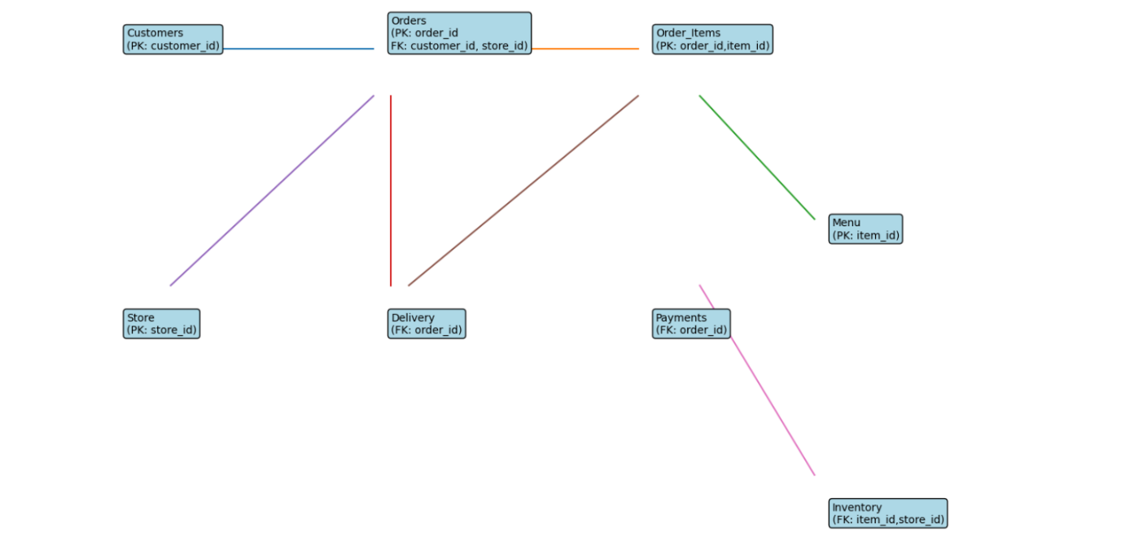
There is a need to do data analysis using these tables and columns to find the suitable data insights so as to give business insights to improve the operational efficiency, customer experience, and overall business performance.
There are various types of analysis that can be done for QSR industries. Here are some of the notable topics where data analysis can be performed:-

1. Sales Analysis
Objective
To analyze overall revenue performance and identify sales trends over time.
Approach
Order data is aggregated based on time (daily/weekly/monthly) to calculate:
- Total revenue
- Number of orders
- Average order value
Key Insights
Sales typically show time-based patterns, with higher revenue during weekends and peak hours (evenings). Sudden drops in sales may indicate operational issues or reduced demand.
Business Impact
- Helps in forecasting demand
- Enables targeted promotions during low-sales periods
- Assists in capacity planning
SQL Query

Daily Revenue & Orders
SELECT
DATE(order_time) AS order_date,
COUNT(order_id) AS total_orders,
SUM(order_value) AS total_revenue,
AVG(order_value) AS avg_order_value
FROM Orders
GROUP BY DATE(order_time)
ORDER BY order_date;

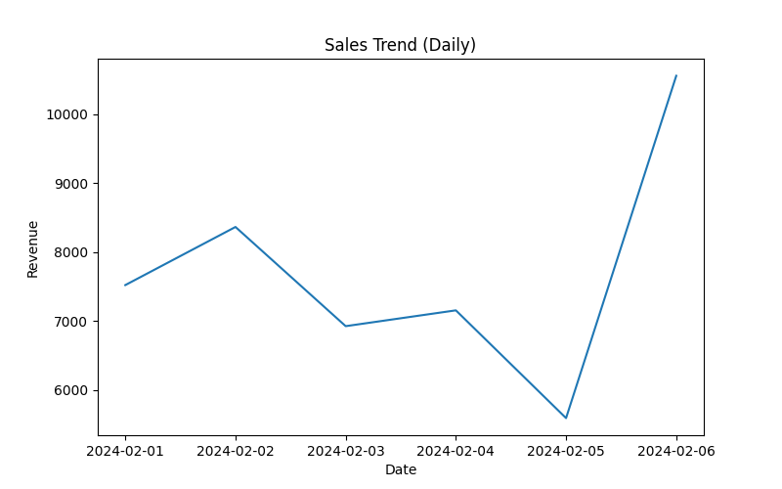

2. Menu Performance Analysis
Objective
To evaluate the performance of menu items and identify high and low contributors.
Approach
Order item data is joined with menu data to calculate:
- Total quantity sold per item
- Revenue generated per item
Key Insights
Analysis typically reveals that:
- A small percentage of items contribute to the majority of revenue (Pareto principle or 80-20 rule)
- Some items have consistently low demand
Business Impact
- Remove or improve low-performing items
- Highlight top-selling items in promotions
- Create combo offers using frequently ordered items

SQL Query
Item-wise Sales & Revenue
SELECT
m.item_name,
SUM(oi.quantity) AS total_quantity_sold,
SUM(oi.quantity * m.price) AS total_revenue
FROM Order_Items oi
JOIN Menu m ON oi.item_id = m.item_id
GROUP BY m.item_name
ORDER BY total_revenue DESC;

Top 3 Selling Items
SELECT
m.item_name,
SUM(oi.quantity) AS total_sold
FROM Order_Items oi
JOIN Menu m ON oi.item_id = m.item_id
GROUP BY m.item_name
ORDER BY total_sold DESC
LIMIT 3;

Low Performing Items
SELECT
m.item_name,
SUM(oi.quantity) AS total_sold
FROM Order_Items oi
JOIN Menu m ON oi.item_id = m.item_id
GROUP BY m.item_name
ORDER BY total_sold ASC;
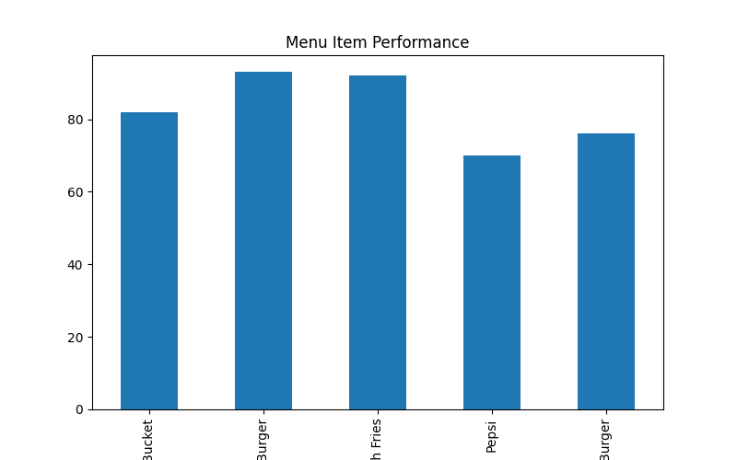
3. Delivery Performance Analysis
Objective
To measure delivery efficiency and identify delays in order fulfillment.
Approach
Delivery time is calculated as:
Delivery Time – Order Time
Metrics analyzed:
- Average delivery time
- Percentage of delayed orders
- Delivery performance across time
Key Insights
- Delivery delays increase during peak hours
- Some orders exceed expected delivery thresholds
Business Impact
- Optimize delivery staffing
- Improve routing strategies
- Enhance customer satisfaction

SQL Query
Average Delivery Time
SELECT
AVG(EXTRACT(EPOCH FROM (d.delivery_time - o.order_time)) / 60) AS avg_delivery_minutes
FROM Orders o
JOIN Delivery d ON o.order_id = d.order_id;

Late Deliveries (>30 min)
SELECT
o.order_id,
(d.delivery_time - o.order_time) AS delivery_duration
FROM Orders o
JOIN Delivery d ON o.order_id = d.order_id
WHERE d.delivery_time - o.order_time > INTERVAL '30 minutes';

Percentage of Late Deliveries
SELECT
COUNT(*) FILTER (
WHERE d.delivery_time - o.order_time > INTERVAL '30 minutes'
) * 100.0 / COUNT(*) AS late_delivery_percentage
FROM Orders o
JOIN Delivery d ON o.order_id = d.order_id;
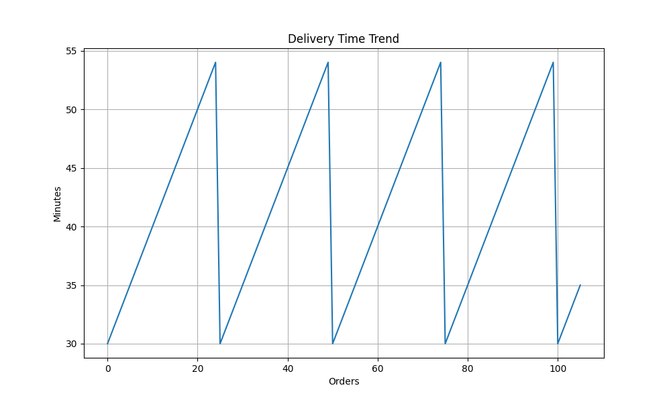
4. Peak Hour Analysis
Objective
To identify high-demand time periods.
Approach
Orders are grouped by hour of the day to determine:
- Order volume per hour
Key Insights
- Highest demand typically occurs during lunch (12–2 PM) and dinner (7–9 PM)
Business Impact
- Allocate more staff during peak hours
- Reduce waiting and delivery times
- Improve operational efficiency

SQL Query
Orders by Hour
SELECT
EXTRACT(HOUR FROM order_time) AS hour,
COUNT(order_id) AS total_orders
FROM Orders
GROUP BY hour
ORDER BY total_orders DESC; 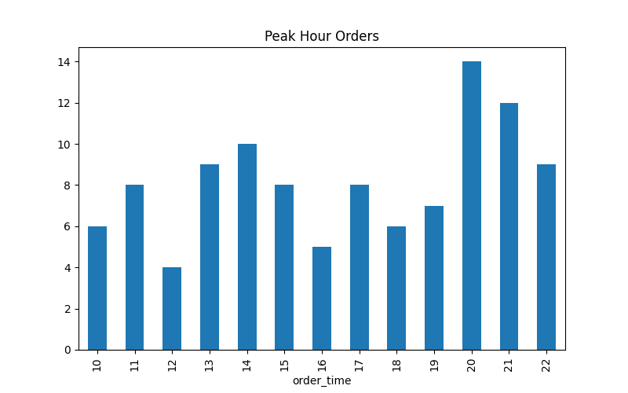

5. Customer Analysis
Objective
To understand customer behavior and identify high-value customers.
Approach
Customer-level aggregation is performed to calculate:
- Total orders per customer
- Total spending
Key Insights
- A small group of customers contributes significantly to revenue
- These are high-value or loyal customers
Business Impact
- Target high-value customers with exclusive offers
- Improve personalization
- Increase customer lifetime value

SQL Query
Customer Spend & Orders
SELECT
customer_id,
COUNT(order_id) AS total_orders,
SUM(order_value) AS total_spent
FROM Orders
GROUP BY customer_id
ORDER BY total_spent DESC;

Top Customers
SELECT
customer_id,
SUM(order_value) AS total_spent
FROM Orders
GROUP BY customer_id
ORDER BY total_spent DESC
LIMIT 3;
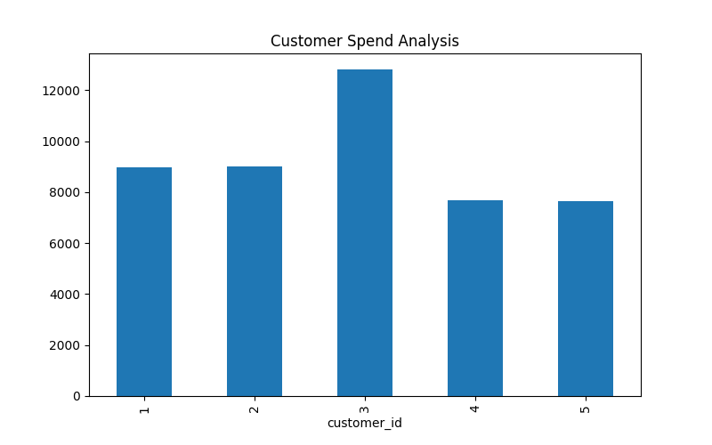
6. Customer Retention Analysis
Objective
To evaluate customer loyalty and repeat behavior.
Approach
Customers are classified as:
- One-time customers
- Repeat customers
Key Insights
- A high percentage of one-time users indicates poor retention
- Repeat customers are key drivers of revenue
Business Impact
- Introduce loyalty programs
- Offer discounts for repeat purchases
- Improve long-term profitability

SQL Query
One-time vs Repeat Customers
SELECT
CASE
WHEN order_count = 1 THEN 'One-time'
ELSE 'Repeat'
END AS customer_type,
COUNT(*) AS total_customers
FROM (
SELECT customer_id, COUNT(order_id) AS order_count
FROM Orders
GROUP BY customer_id
) t
GROUP BY customer_type;
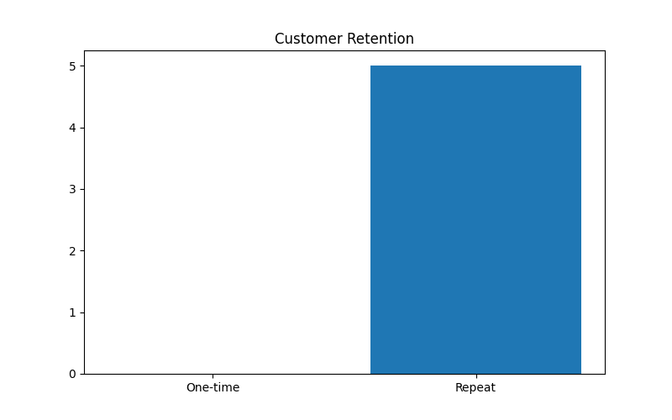
7. Payment Analysis
Objective
To analyze customer payment preferences.
Approach
Payment data is grouped by method to calculate:
- Total revenue per payment type
Key Insights
- Certain payment methods (e.g., UPI, cards) dominate
- Some methods may have low adoption
Business Impact
- Optimize payment experience
- Offer targeted discounts (e.g., UPI cashback)
- Improve checkout efficiency

SQL Query
Revenue by Payment Method
SELECT
payment_method,
SUM(amount) AS total_revenue
FROM Payments
GROUP BY payment_method
ORDER BY total_revenue DESC;
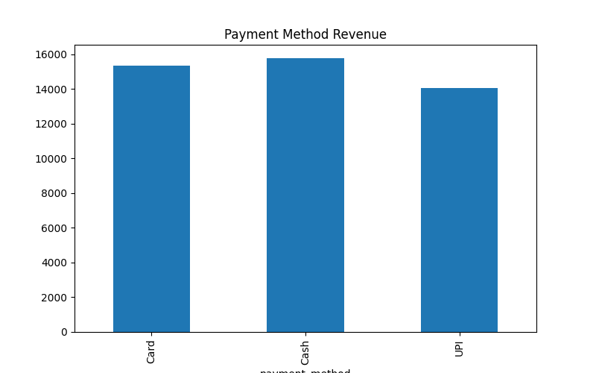
8. Store Performance Analysis
Objective
To compare performance across different store locations.
Approach
Orders are grouped by store to calculate:
- Total orders
- Total revenue
Key Insights
- Some stores consistently outperform others
- Poor-performing stores may have operational issues
Business Impact
- Identify best practices from top stores
- Improve underperforming locations
- Optimize resource allocation

SQL Query
Orders & Revenue per Store
SELECT
s.store_name,
COUNT(o.order_id) AS total_orders,
SUM(o.order_value) AS total_revenue
FROM Stores
JOIN Orders o ON s.store_id = o.store_id
GROUP BY s.store_name
ORDER BY total_revenue DESC;
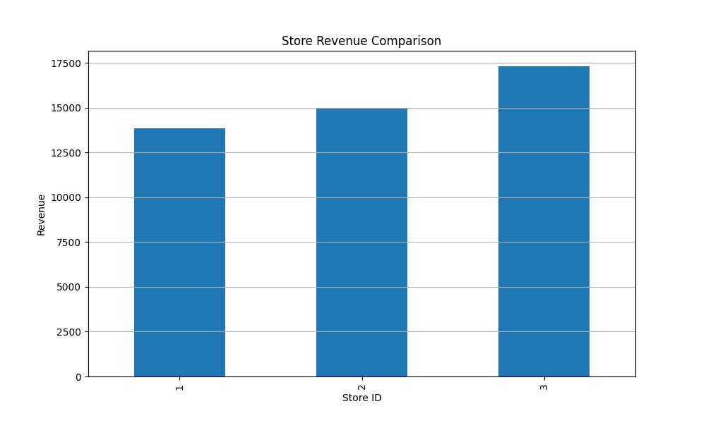
9. Inventory Analysis
Objective
To monitor stock levels and prevent shortages or wastage.
Approach
Inventory data is analyzed to track:
- Current stock levels
- Fast-moving vs slow-moving items
Key Insights
- Some items frequently go out of stock
- Others remain unsold for long periods
Business Impact
- Improve demand forecasting
- Reduce food wastage
- Ensure availability of popular items

SQL Query
Current Stock by Item
SELECT
s.store_name,
m.item_name,
i.stock_quantity
FROM Inventory i
JOIN Menu m ON i.item_id = m.item_id
JOIN Store s ON i.store_id = s.store_id;

Low Stock Items (<20 units)
SELECT
m.item_name,
i.stock_quantity
FROM Inventory i
JOIN Menu m ON i.item_id = m.item_id
WHERE i.stock_quantity < 20;
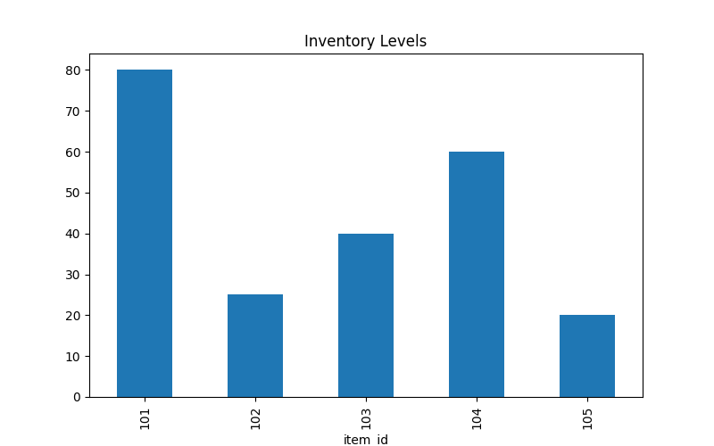
10. Order Value Analysis
Objective
To understand spending patterns per order.
Approach
Calculate:
- Average Order Value (AOV)
Key Insights
- Low AOV indicates smaller orders
- Opportunity to increase revenue per order
Business Impact
- Introduce combo meals
- Offer upselling (add-ons, beverages)

SQL Query
Average Order Value
SELECT
AVG(order_value) AS avg_order_value
FROM Orders;

High Value Orders (>500)
SELECT
order_id,
order_value
FROM Orders
WHERE order_value > 500;
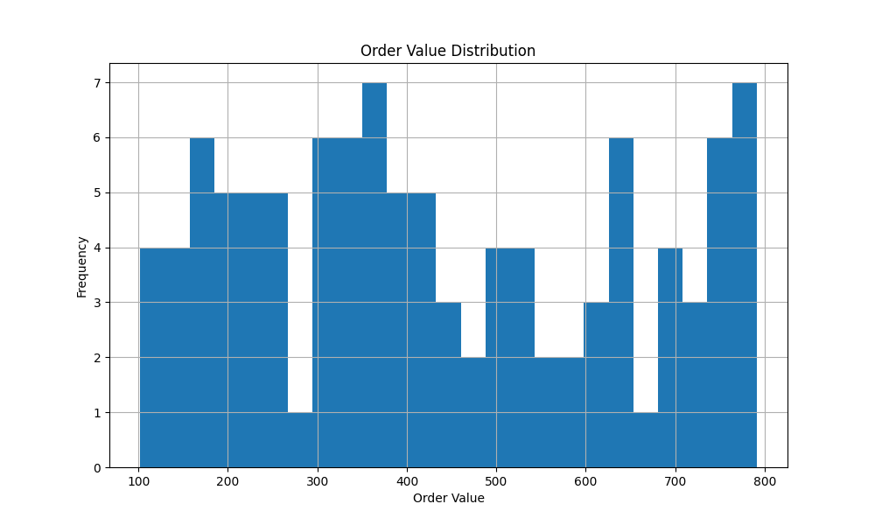
The datasets will be provided in an Excel sheet in another attachment.
Final Business Insights
Based on the data analysis performed on the QSR dataset, the following key business insights have been derived:
1. Revenue & Sales Insights
Insight
Revenue shows fluctuations across days and hours, with clear peaks during specific time periods.
Meaning
Demand is time-dependent, not uniform.
Action
- Focus promotions during low-demand periods
- Forecast demand for better planning
- Optimize staffing based on sales patterns

2. Menu Performance Insights
Insight
A small number of menu items contribute to the majority of total sales (Pareto principle).
Meaning
Menu is not equally efficient.
Action
- Promote top-performing items
- Remove or redesign low-performing items
- Create combo offers using popular items

3. Delivery Performance Insights
Insight
Delivery times vary significantly, with delays during peak hours.
Meaning
Operational inefficiencies exist during high demand.
Action
- Increase delivery capacity during peak hours
- Optimize routing and batching
- Monitor delivery SLAs

4. Peak Hour Insights
Insight
Orders are concentrated during lunch and dinner hours.
Meaning
Demand is clustered, not evenly distributed.
Action
- Allocate more staff during peak hours
- Pre-prepare high-demand items
- Improve kitchen efficiency

5. Customer Insights
Insight
A small group of customers contributes a large portion of revenue.
Meaning
Presence of high-value customers.
Action
- Target high-value customers with offers
- Personalize recommendations
- Build loyalty programs

6. Customer Retention Insights
Insight
Majority of customers are one-time users.
Meaning
Low retention → high dependency on new customers.
Action
- Introduce loyalty programs
- Offer repeat discounts
- Improve customer experience

7. Payment Behaviour Insights
Insight
Digital payments (UPI/Card) dominate transactions.
Meaning
Customers prefer cashless convenience.
Action
- Promote digital payment offers
- Partner with payment platforms
- Improve checkout speed

8. Store Performance Insights
Insight
Revenue and order volume vary across stores.
Meaning
Some stores are more efficient than others.
Action
- Identify best-performing stores
- Replicate successful strategies
- Improve underperforming locations

9. Inventory Insights
Insight
Some items are understocked while others are overstocked.
Meaning
Inventory planning is not optimized.
Action
- Use demand forecasting
- Maintain optimal stock levels
- Reduce wastage

10. Order Value Insights
Insight
Most orders fall within a mid-range value.
Meaning
Opportunity to increase revenue per order.
Action
- Introduce combo meals
- Upsell add-ons
- Offer minimum order discounts

11. Operational Bottlenecks (Critical Insight)
Insight
Delivery delays + peak hour congestion + inventory mismatch
Meaning
Core operations need optimization.
Action
- Improve process automation
- Optimize workforce allocation
- Use real-time monitoring

Conclusion:
The study effectively demonstrates how a data-centric approach enables QSR businesses to align operational efficiency with customer expectations. By integrating analytics into decision-making, organizations can achieve scalable growth, competitive advantage, and long-term business sustainability.

